Cambios en el Help Setup – Step 5
Modificar este párrafo por el que esta debajo
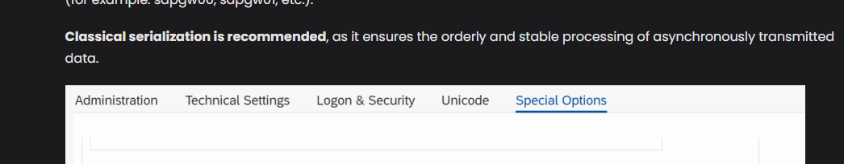
Special Options
Classical serialization ("classic") must be configured, as it is the setting that ensures the orderly and stable processing of asynchronously transmitted data. If left configured as "fast" (or any option other than "classic"), the connection will fail and produce the following error: [JCO ERROR SYSTEM FAILURE: Index -1 out of bounds for length 0 RFC ERROR SYSTEM – Message number: 341].
Debajo de este párrafo agregar la nota debajo
Note on handling extractions: By default, Crestone uses a single RFC connection (CRESTONE_SERVER) to communicate with the SAP system, which means that extractions are executed sequentially—that is, an RFC connection can only process one extraction at a time. If your scenario requires running multiple extractions simultaneously, see the "Using Parallelism: Additional RFC Connections (Slots)" section below.
Agregar la opción 5 antes de verification y agregar lo siguiente
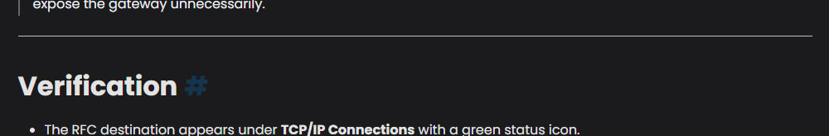
5. Use of parallelism: additional RFC connections (slots)
Each extraction performed by Crestone consumes one RFC connection. With only one connection configured (CRESTONE_SERVER), extractions can only be processed sequentially, one at a time.
If parallel processing is to be enabled, additional RFC connections must be created in SM59, following the same procedure detailed in steps 2) Maintain the RFC Destination, 3) Test the Connection, and 4) Configure SAP Gateway Security, using EXACTLY the following destination names:
- CRESTONE_SERVER_SLOT_01
- CRESTONE_SERVER_SLOT_02
- CRESTONE_SERVER_SLOT_03
- CRESTONE_SERVER_SLOT_04
- CRESTONE_SERVER_SLOT_05
Important:
These are the only slot names supported by the platform; Crestone recognizes a maximum of 5 slots, predefined with these exact names. No variants are supported (different names, different numbering, or a quantity greater than 5); any RFC connection created with a different name will not be recognized by Crestone as a valid parallelism slot.
When configuring each slot, every reference to CRESTONE_SERVER must be replaced with the corresponding slot name, in all fields and steps where applicable. For example, if configuring CRESTONE_SERVER_SLOT_01:
- RFC Destination (step 2): CRESTONE_SERVER_SLOT_01
- Program ID (step 2): CRESTONE_SERVER_SLOT_01 (must match the ID configured in the Crestone connector for that slot)
- secinfo file (step 4): TP: CRESTONE_SERVER_SLOT_01
- reginfo file (step 4): TP: CRESTONE_SERVER_SLOT_01
The remaining technical parameters (connection type, activation type, gateway host/service, classical serialization, and conversion of outgoing bgRFC calls to outgoing qRFC calls) remain the same as in the CRESTONE_SERVER configuration.
Note: the number of RFC connections created defines the maximum degree of parallelism available. For example, with 5 slots configured, Crestone will be able to run up to 5 simultaneous extractions; without additional connections, processing will be strictly sequential.
Platform-side activation: in addition to the SAP-side configuration, parallelism must be enabled from the Crestone configuration (Settings → Extraction → RFC Parallelism), where an option exists to turn this mode on or off. If parallelism is disabled, Crestone will use only the CRESTONE_SERVER connection sequentially, even if additional slots are configured in SAP.

Modificaciones en Sectin > Nodes >Sql Editor > Variables
Quitar el párrafo repetido de Execution of jobs en esta sección al final
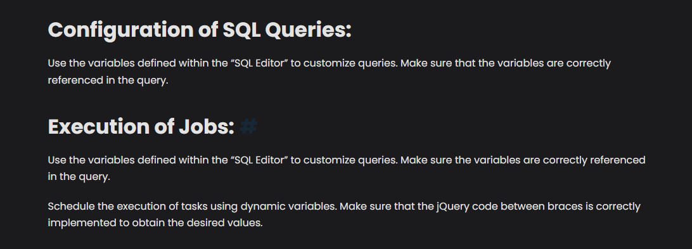
Modificar JQuery por Jinja2
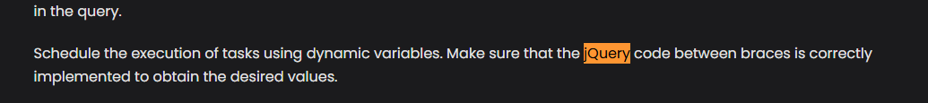

Modificar las imágenes de la sección variables por estas de abajo
Types of variables
Hardd text
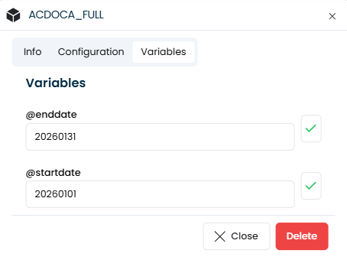
Python code
Agregar debajo del titulo lo siguiente
Examples of use — Python code:
• First day of the current month:
{{ today().replace(day=1).strftime('%Y%m%d') }}
• Last day of the current month:
{{ ((today().replace(day=28) + timedelta(days=4)).replace(day=1) - timedelta(days=1)).strftime('%Y%m%d') }}
Important: In Python code, text strings must be enclosed in single quotes ('...'), not double quotes.

Y reemplazar la imagen
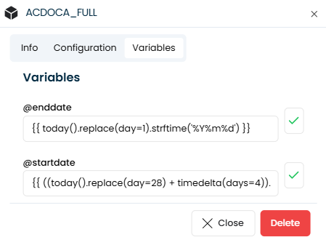
Modificar el text
Por
Within the SQL Editor, you can use these variables to create dynamic SQL queries. Important: When referencing the variable in the WHERE clause, it must be enclosed in single quotes to avoid syntax errors. Example:
SELECT * FROM table WHERE date = ‘@date’
Implementación
Remmplezar imagen por esta
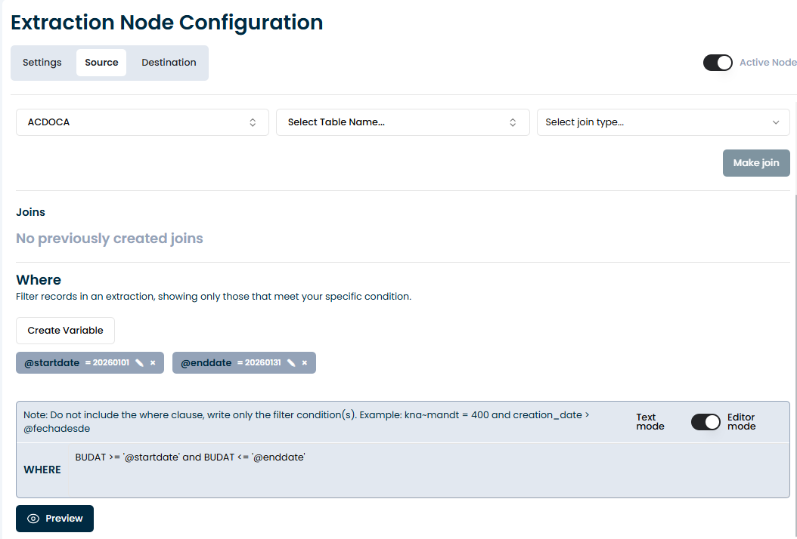
Dentro de configuration of Sql Queries remmplazar el texto
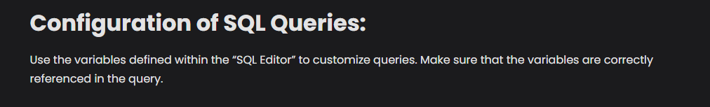
Por
Use the variables defined in the SQL Editor to customize your queries. Ensure that variables are correctly referenced within single quotes ('@variable') to avoid syntax errors.

Modificaciones en Incremental Loads
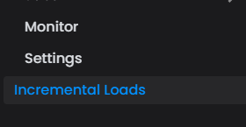
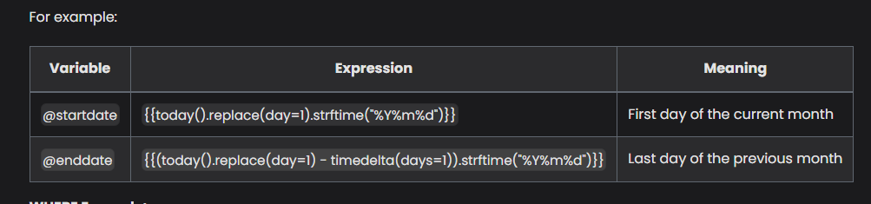
Modificar el texto ya que no usa comillas dobles las expresiones
{{ today().replace(day=1).strftime('%Y%m%d') }}

{{ ((today().replace(day=28) + timedelta(days=4)).replace(day=1) - timedelta(days=1)).strftime('%Y%m%d') }}
Modificar el texto del example

Por
VBAK-ERDAT >= ‘@startdate’
Agregar debajo de esto
Important: Within the Python code for the variable, text strings must be enclosed in single quotes ('...'), not double quotes. Also, when using the variable in the SQL Editor, it is important to enclose '@variable' in single quotes within the WHERE clause to avoid syntax conflicts.
Y modificar las imágenes en considerations por estas

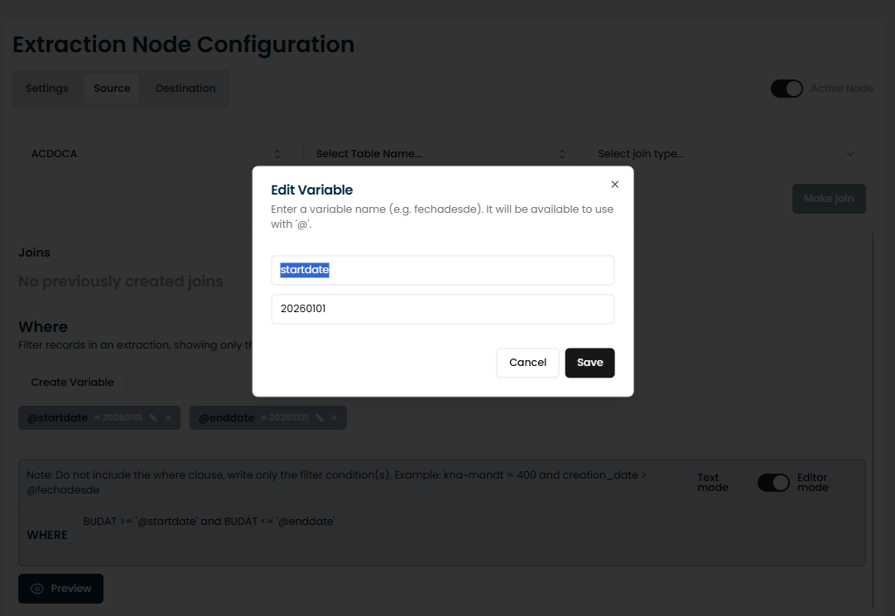
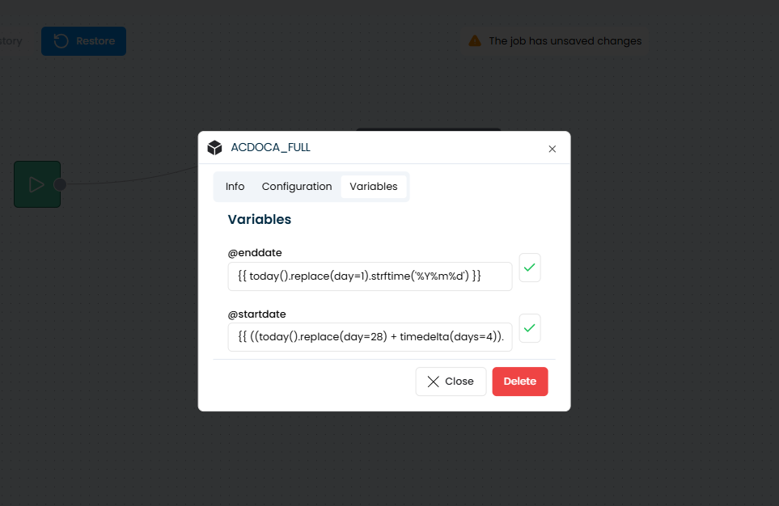

Cambios en reportes
Cambiar las imágenes viejas por esta nueva de la 1-6.
Dejar de la 7 hacia adelante
https://scribehow.com/o/PYdZJaN6Qom2KlD3K_OPMw/viewer/How_to_Configure_SAP_ECC_60_FBL3N_Report_Variants__SuxLHMHVTCuj9kYo7MflEA

Docu nueva sobre report Batch
Lo agregaría al final del punto 12 o como una opción de reporte en el menú, eso lo dejamos a tu criterio
https://scribehow.com/o/PYdZJaN6Qom2KlD3K_OPMw/viewer/Configuring_Batch_Data_Processing_and_File_Splitting__Z2sLGJ9WTZOIBGygfKar8Q
z

